**Full Introduction**

**"Good evening, thank you for this opportunity. My name is Afzal Hussain, a front-end developer with 3+ years of experience in Angular. I currently work at Bajaj Finance Ltd.

My expertise in Angular, TypeScript, JavaScript, Angular Material and API integration. I’ve worked on projects like an Asset Tracking System and a Payment Gateway.

Since I’m serving my notice period, I’m looking for a new opportunity."**

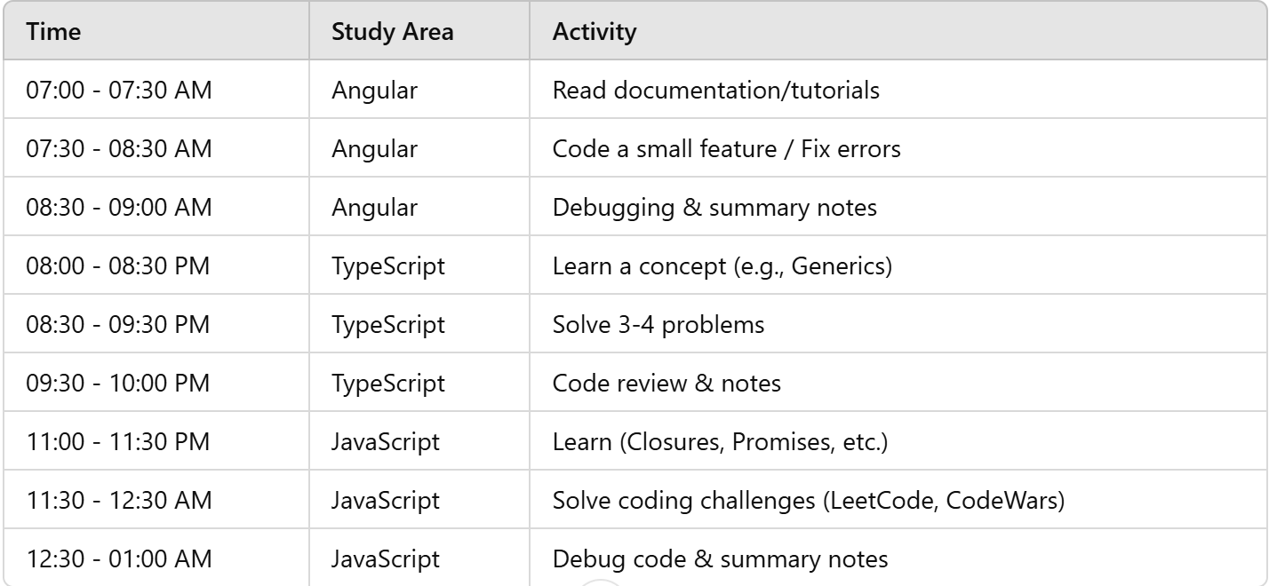

To strengthen your JavaScript basics, here’s a step-by-step list of concepts to focus on:

1. **Variables and** **Data Types** (var, let, const, string, number, boolean, null, undefined, symbol, BigInt)
2. **Operators** (Arithmetic, Comparison, Logical, Assignment, Ternary)
3. **Control Structures** (if, else, switch, for, while, do-while, break, continue)
4. **Functions** (Function declaration, Function expressions, Arrow functions, IIFE)
5. **Scope and** **Closures** (Global scope, Local scope, Lexical scope, Closure)
6. **Hoisting** (Variable hoisting, Function hoisting)
7. **Objects** (Object creation, Object methods, Object destructuring)
8. **Arrays** (Array methods, Array manipulation, Array destructuring)
9. **Prototype and Inheritance** (Prototype chain, Inheritance, this keyword)
10. **Asynchronous JavaScript** (Callbacks, Promises, async/await)
11. **Error Handling** (try-catch, throwing errors)
12. **Modules** (Export, Import, ES6 Modules)
13. **Event Loop** (Call stack, Callback queue, Event loop, Microtasks)
14. **DOM Manipulation** (Selecting elements, Event listeners, DOM methods)
15. **ES6+ Features** (Template literals, Destructuring, Spread and Rest operators, Default parameters, Classes)
16. **Functional Programming** (Map, Filter, Reduce, Functions as First-Class Citizens)
17. **JSON** (Parsing, Stringifying)
18. **Regular Expressions** (RegEx syntax, Methods)
19. **Memory Management** (Garbage Collection, Memory leaks)
20. **Design Patterns** (Factory, Singleton, Module, Observer)

The list I provided covers the core JavaScript concepts that form a strong foundation for understanding the language. However, here are a few additional advanced concepts and topics that will deepen your knowledge further:

1. **WeakMap and WeakSet** (Understanding weak references and their use cases)
2. **Modules System** (CommonJS, AMD, UMD vs ES Modules, Dynamic imports)
3. **Memory Management and Optimization** (Stack vs Heap, Optimizing performance, Throttling, Debouncing)
4. **Deep Cloning** (Shallow vs deep cloning, Object.assign(), JSON.parse()/JSON.stringify())
5. **Iterators and Generators** (Creating custom iterators, for...of, Generators with yield)
6. **Event Delegation** (Optimizing event handling for performance)
7. **Web APIs** (Fetch, LocalStorage, SessionStorage, IndexedDB, Geolocation, Canvas, WebSockets)
8. **Service Workers** (Caching, Background sync, Progressive Web Apps)
9. **Progressive Enhancement** (Graceful degradation, Fallback strategies for modern features)
10. **Security Basics** (XSS, CSRF, CORS, Content Security Policy, HTTPS)
11. **TypeScript Basics** (Type annotations, Interfaces, Types, Generics, Enums)
12. **Testing** (Unit Testing with Jasmine or Mocha, Test-Driven Development, Mocking, Sinon.js)
13. **Design Patterns** (Observer Pattern, Strategy Pattern, Decorator Pattern, Singleton Pattern in JS)
14. **Reactive Programming** (RxJS, Observables, Subscriptions, Operators like map, filter, merge)
15. **State Management** (State management patterns like Flux, Redux, and Context API in JS)
16. **Web Components** (Custom Elements, Shadow DOM, HTML Templates)
17. **Node.js Basics** (Understanding Node.js runtime, Express.js, API Building, File System operations)
18. **Functional Programming in JS** (Pure functions, Higher-order functions, Immutability, Recursion)
19. **Asynchronous Iterators** (Handling async flows using iterators)
20. **Designing Scalable Web Applications** (Component-based architecture, Single Page Applications, Server-Side Rendering)

**Basic TypeScript Concepts**

1. **Basic Types** (string, number, boolean, null, undefined, void, any, unknown, never, object, tuple, enum)
2. **Type Annotations** (Explicit vs Implicit types)
3. **Type Inference** (How TypeScript infers types automatically)
4. **Union & Intersection Types** (Combining multiple types)
5. **Type Aliases** (type keyword for reusable types)
6. **Interfaces** (Defining object structures, extending interfaces)
7. **Classes & OOP** (Class, Inheritance, Access Modifiers, Abstract Classes)
8. **Functions** (Typed parameters, return types, optional/default parameters, rest parameters)
9. **Arrow Functions** (Syntax and usage in TypeScript)
10. **Generics** (Creating reusable and flexible components)
11. **Enums** (Numeric and string enums, usage and best practices)
12. **Type Assertions** (as keyword, angle-bracket syntax, non-null assertion)
13. **Readonly & Const Assertions** (Immutable variables and properties)
14. **Mapped Types** (Partial<T>, Readonly<T>, Pick<T>, Omit<T>)
15. **Utility Types** (Record<T, K>, Exclude<T, U>, Extract<T, U>, ReturnType<T>, Parameters<T>)
16. **Type Guards** (typeof, instanceof, custom type guards)
17. **Discriminated Unions** (Type-safe handling of different object shapes)
18. **Literal Types** (String literals, numeric literals, boolean literals)
19. **Modules & Namespaces** (Import/export, organizing code in modules)
20. **Decorators** (@Component, @Injectable, method/property decorators)

**Advanced TypeScript Concepts**

1. **Intersection Types** (Combining multiple types into one)
2. **Keyof and Lookup Types** (keyof, indexed access types)
3. **Conditional Types** (T extends U ? X : Y syntax)
4. **Template Literal Types** (Creating dynamic string types)
5. **Infer Keyword** (Extracting type information dynamically)
6. **Declaration Merging** (Merging interfaces and module declarations)
7. **Type Compatibility** (Structural typing in TypeScript)
8. **Strict Mode** (strict, strictNullChecks, strictPropertyInitialization)
9. **Optional Chaining & Nullish Coalescing** (?. and ?? operators)
10. **TypeScript with JavaScript** (Using .d.ts declaration files)
11. **Working with Third-Party Libraries** (@types/, DefinitelyTyped)
12. **Type-Safe Event Handling** (Event types in TypeScript)
13. **TypeScript with React** (Props, State, Hooks with TypeScript)
14. **TypeScript with Angular** (Component typing, Services, Dependency Injection)
15. **TypeScript with Node.js** (Using TypeScript for backend development)
16. **Functional Programming in TypeScript** (Pure functions, immutability, function composition)
17. **Performance Optimization in TypeScript** (Reducing bundle size, optimizing types)
18. **Unit Testing with TypeScript** (Jest, Jasmine, Mocha with TypeScript)
19. **Error Handling in TypeScript** (try-catch, custom error types, error boundaries)
20. **Best Practices & Design Patterns in TypeScript** (Singleton, Factory, Observer, Dependency Injection)

To build a strong understanding of **Angular** concepts for real-world projects, you should focus on the following areas:

**1. Angular Core Concepts**

🔹 **Modules and Architecture**

* **NgModules** (@NgModule)
* **Standalone Components** (from Angular 17+)
* **Feature Modules & Lazy Loading**
* **Shared Modules**
* **Core Module (Singleton Services)**

🔹 **Components and Templates**

* **Component Lifecycle Hooks** (ngOnInit, ngOnChanges, ngAfterViewInit, etc.)
* **Change Detection Strategies** (Default & OnPush)
* **ViewEncapsulation** (Emulated, None, ShadowDom)
* **Dynamic Components (ViewContainerRef, ComponentFactoryResolver)**

🔹 **Directives**

* **Structural Directives** (*ngIf, *ngFor, *ngSwitch)
* **Attribute Directives** ([ngClass], [ngStyle])
* **Custom Directives**

🔹 **Pipes**

* **Built-in Pipes** (date, currency, uppercase, async, etc.)
* **Custom Pipes** (Pure & Impure Pipes)
* **Pipe Chaining & Performance Considerations**

**2. Data Binding & Forms**

🔹 **Data Binding**

* **One-way Binding** ({{}}, [], (), bind-*)
* **Two-way Binding** ([(ngModel)])
* **Event Binding ((click), (keyup))**
* **Template Reference Variables (#var)**

🔹 **Forms**

* **Reactive Forms (FormGroup, FormControl, FormBuilder)**
* **Template-driven Forms**
* **Validation (Built-in & Custom)**
* **Async Validators**
* **Dynamic Forms Handling**

**3. Services & Dependency Injection**

* **Singleton Services (providedIn: 'root')**
* **Injection Tokens**
* **Multi-provider Services**
* **Hierarchical Dependency Injection**
* **Inter-component Communication (@Input, @Output, EventEmitter, BehaviorSubject)**

**4. State Management**

* **RxJS & Observables (subscribe, pipe, map, filter, etc.)**
* **BehaviorSubject vs Subject**
* **NgRx Store (Redux for Angular)**
* **Component Store (Lightweight State Management)**

**5. Routing & Navigation**

* **Router Module (RouterModule.forRoot, RouterModule.forChild)**
* **Lazy Loading & Preloading Strategies**
* **Route Guards (CanActivate, CanDeactivate, Resolve, CanLoad)**
* **Route Parameters & Query Params**
* **Nested Routing & Auxiliary Routes**
* **Router Events & Navigation Interception**

**6. HTTP Client & API Integration**

* **HttpClientModule**
* **GET, POST, PUT, DELETE requests**
* **Handling Observables with RxJS Operators**
* **Interceptors (Request & Response Interceptors)**
* **Error Handling & Retry Mechanism**
* **Caching & Optimizing API Calls**

**7. Angular Material & UI Components**

* **Material Components (Table, Dialog, Form Field, Snackbar, etc.)**
* **Theming & Custom Styles**
* **CDK (Component Dev Kit) - Drag & Drop, Overlay, Scrolling, Accessibility**
* **Flex Layout & Grid System**

**8. Performance Optimization**

* **OnPush Change Detection Strategy**
* \**TrackBy in ngFor*
* **Lazy Loading Modules**
* **Virtual Scrolling**
* **Debouncing & Throttling (for API Calls)**
* **Caching & Memoization**
* **Optimizing Large Forms & Tables**
* **Web Workers for Heavy Computation**

**9. Security Best Practices**

* **Sanitization (DomSanitizer)**
* **Cross-Site Scripting (XSS) Prevention**
* **Cross-Origin Resource Sharing (CORS)**
* **Authentication & Authorization (JWT, OAuth)**
* **Role-Based Access Control (RBAC)**
* **Rate Limiting & API Security**

**10. Testing & Debugging**

* **Unit Testing (Jasmine & Karma)**
* **Component Testing with TestBed**
* **Service Testing with HttpTestingController**
* **Mocking Dependencies (spyOn, fakeAsync, flush, tick)**
* **E2E Testing with Cypress or Playwright**
* **Debugging with Chrome DevTools & Augury**

**11. Micro Frontends (MFE)**

* **Module Federation (Webpack 5)**
* **Communication between MFEs**
* **Sharing Dependencies**
* **Deployment Strategies**

**12. Server-Side Rendering (SSR) & PWA**

* **Angular Universal (SSR)**
* **Progressive Web Apps (PWAs)**
* **Service Workers**
* **Lazy Loading & Caching Strategies**

**🔹 Core OOP Concepts**

1. **Class & Object**
2. **Encapsulation**
3. **Abstraction**
4. **Inheritance**
5. **Polymorphism**

**🔹 Advanced OOP Concepts**

1. **Interfaces** (TypeScript-specific)
2. **Abstract Classes**
3. **Method Overriding**
4. **Method Overloading** (TypeScript-specific)
5. **Static vs Instance Methods & Properties**
6. **Private, Public, and Protected Modifiers**
7. **Constructors & Super() Keyword**

**🔹 OOP Principles in Angular**

1. **Dependency Injection (DI)**
2. **Singleton Pattern (Used in Services)**
3. **Factory Pattern (For Dynamic Components & Services)**

## **🚀 Summary: Data Structure Types in JavaScript**

### 🔥 ****1. Primitive Data Structures**** (Immutable)

* Number, String, Boolean, Undefined, Null, Symbol, BigInt

### 🔥 ****2. Non-Primitive Data Structures**** (Mutable)

#### ✅ ****Linear Data Structures****

* **Array**, **Stack**, **Queue**, **Linked List**

#### ✅ ****Non-Linear Data Structures****

* **Hash Table (Object & Map)**, **Tree**, **Graph**

#### ✅ ****Special Data Structures****

* **Set**, **WeakMap**, **WeakSet**